Commands for linux :
1.Pwd: present worling directory
2. cd: change directory
3. cd .. : one step back
4. cd ../.. : two step back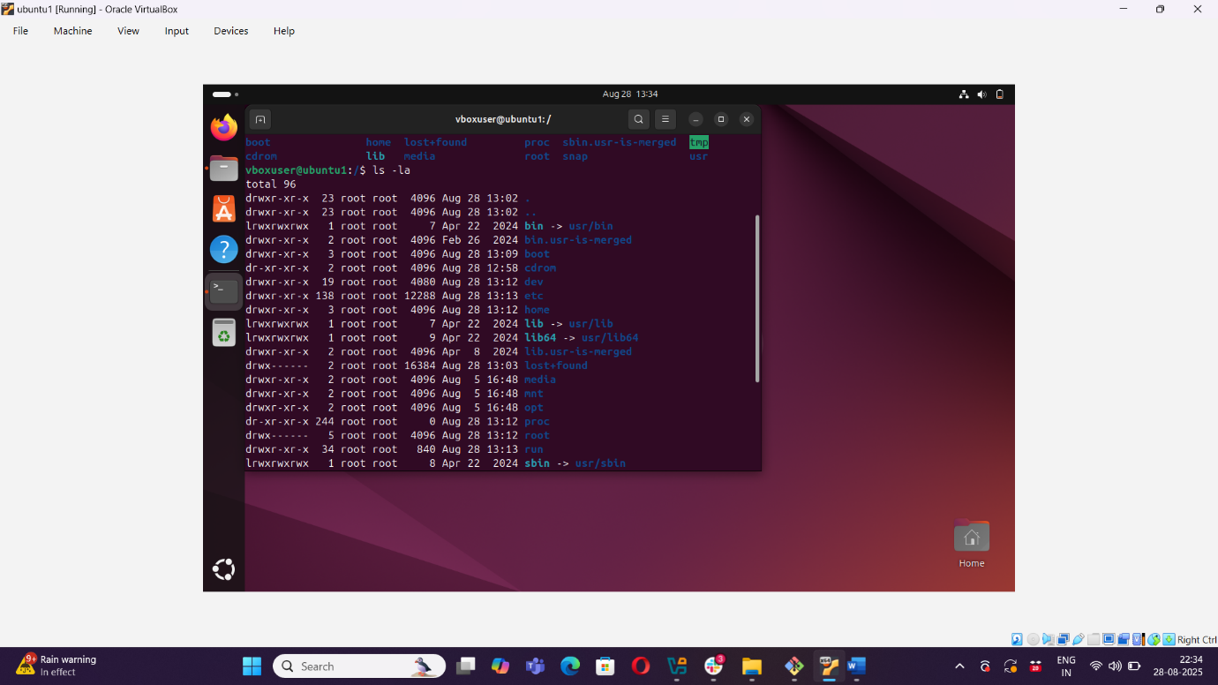
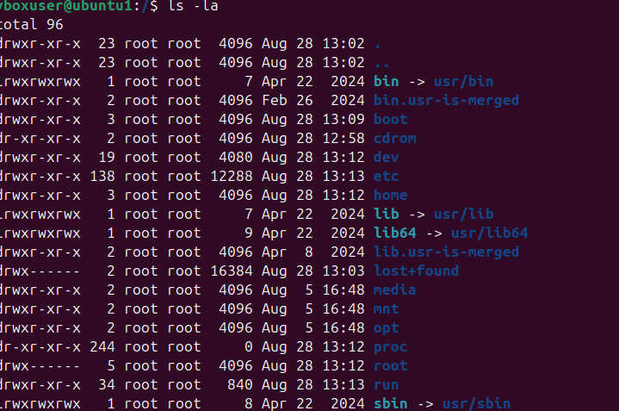5 ls : list of files
6. ls -ls : list of hidden files.
7. ls -ls : list of files in sorting format ( higher volume to lower )
8. ls -d*/ : list all the directories only.
9. wc : will help you to get the details of your file.

